Department | AIML
Course Code / Course Name | DSA0602/ Data Handling and Visualization
Experiment | Data Visualization using R
Name | YASHIKA.R
Register Number | 192525102
Date | 13/10/2026
Day | Tuesday
Set 20: Stock Analysis

1. Line chart — Stock price trends
Aim: To visualize the price movements of three stocks over time.
Algorithm:
- Create a data frame containing dates and stock prices.
- Convert the date column into Date format.
- Reshape the stock prices into long format.
- Draw a line chart with a separate line for each stock.
- Add a legend, title, and axis labels.
Code:
if (!requireNamespace("ggplot2", quietly = TRUE))
install.packages("ggplot2", type = "binary")
if (!requireNamespace("tidyr", quietly = TRUE))
install.packages("tidyr", type = "binary")

library(ggplot2)
library(tidyr)

stocks <- data.frame(
Date = as.Date(c("2023-01-01", "2023-01-02", "2023-01-03")),
`Stock A` = c(100, 105, 110),
`Stock B` = c(150, 152, 148),
`Stock C` = c(120, 118, 122),
check.names = FALSE
)

stock_long <- pivot_longer(
stocks, cols = -Date,
names_to = "Stock", values_to = "Price"
)

ggplot(stock_long, aes(x = Date, y = Price, color = Stock)) +
geom_line(linewidth = 1) +
geom_point(size = 2) +
labs(title = "Stock Price Trends",
x = "Date", y = "Stock Price ($)", color = "Company") +
theme_minimal()
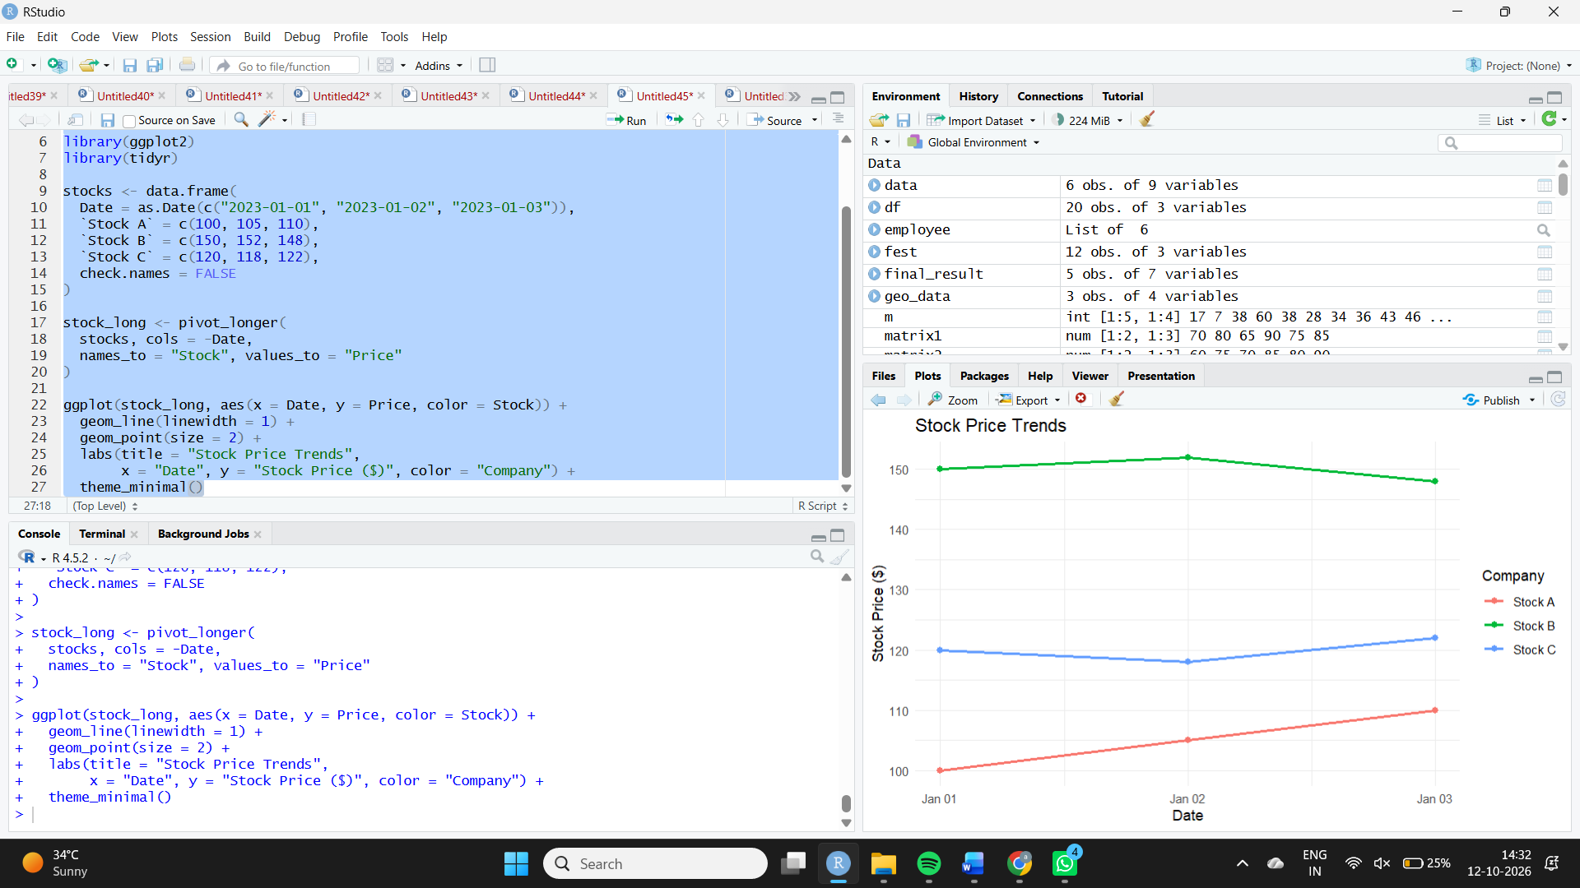
Observation: Stock A increases from $100 to $110. Stock B rises slightly before falling to $148, while Stock C falls to $118 and then recovers to $122.
2. Bar chart — Daily percentage change in Stock A
Aim: To calculate and visualize the daily percentage change in Stock A's price.
Algorithm:
- Extract Stock A prices and dates.
- Calculate percentage change between consecutive days.
- Draw a bar chart with date labels.
- Add a title and axis labels.
Code:
library(ggplot2)

change_data <- data.frame(
Date = stocks$Date[-1],
Change = diff(stocks$`Stock A`) /
head(stocks$`Stock A`, -1) * 100
)

ggplot(change_data, aes(x = Date, y = Change)) +
geom_col(fill = "steelblue") +
labs(title = "Daily Percentage Change in Stock A",
x = "Date", y = "Percentage Change (%)") +
theme_minimal()
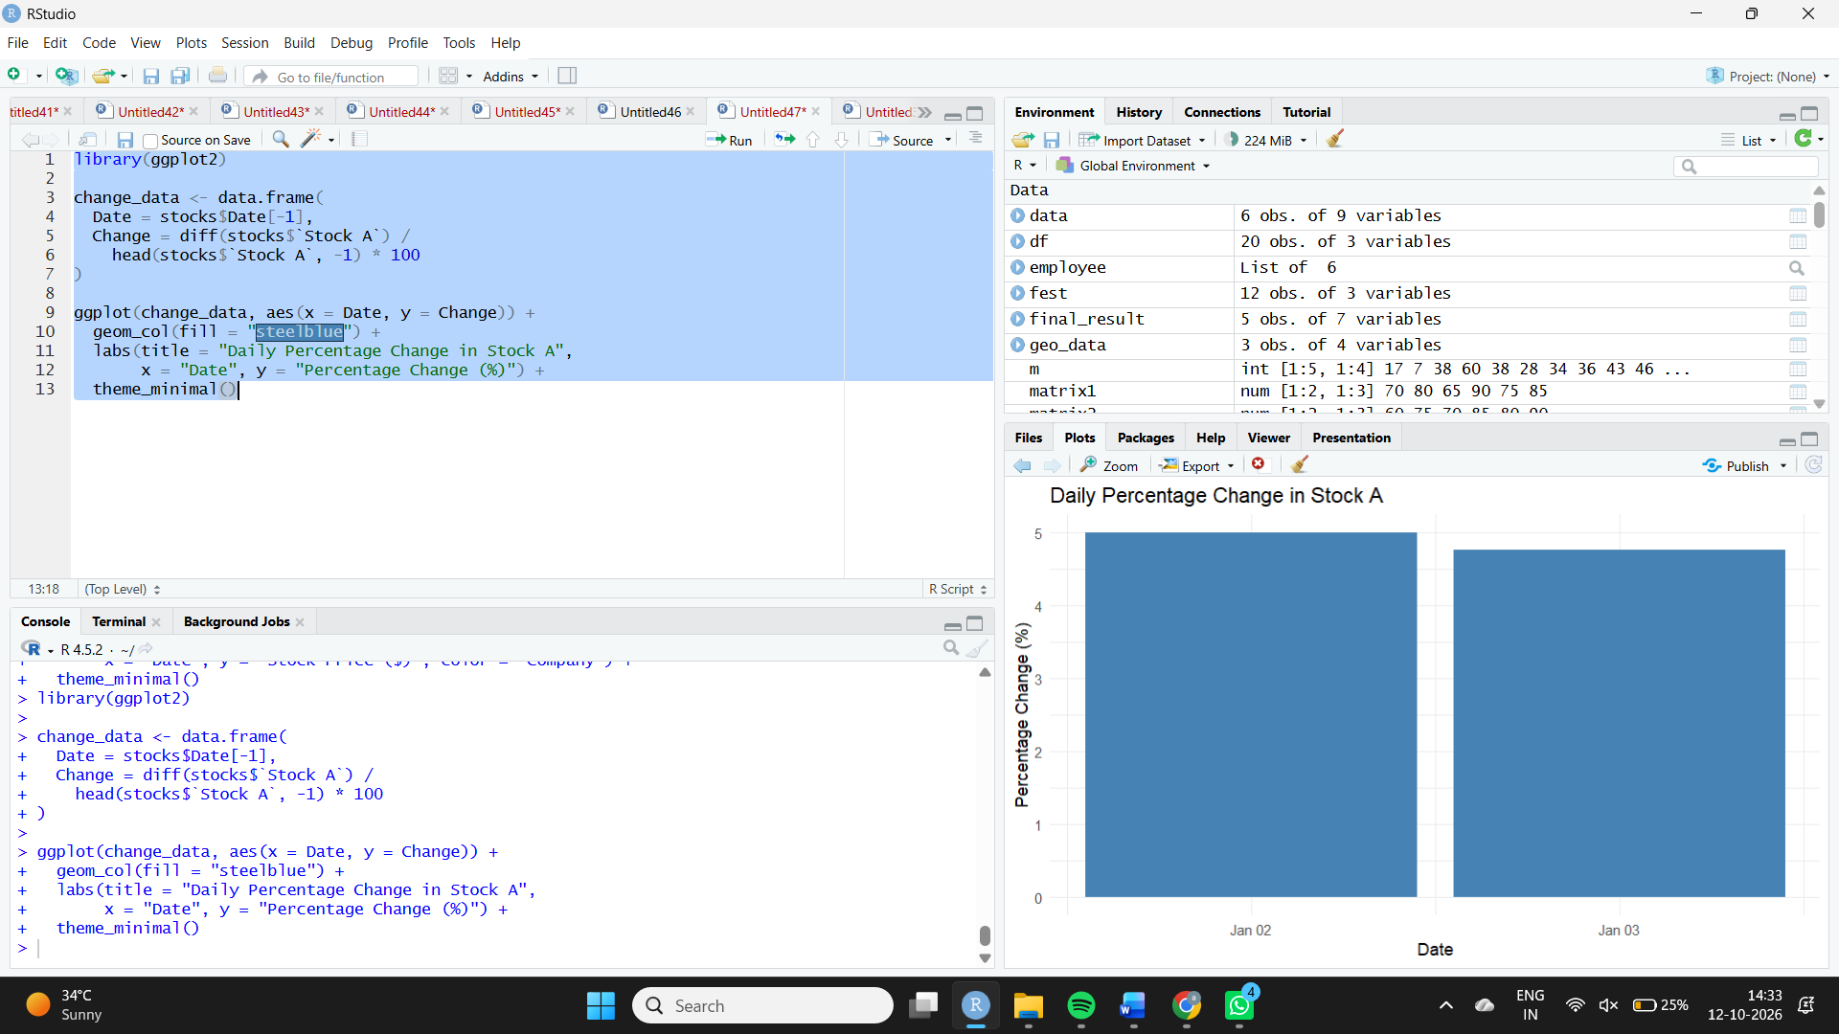
Observation: Stock A increases by 5% from January 1 to January 2 and by approximately 4.76% from January 2 to January 3.
3. Stock price table
Aim: To display the daily closing prices of the three stocks.
Algorithm:
- Store the date and stock prices in a data frame.
- Label the columns.
- Print the table.
Code:
print(stocks)

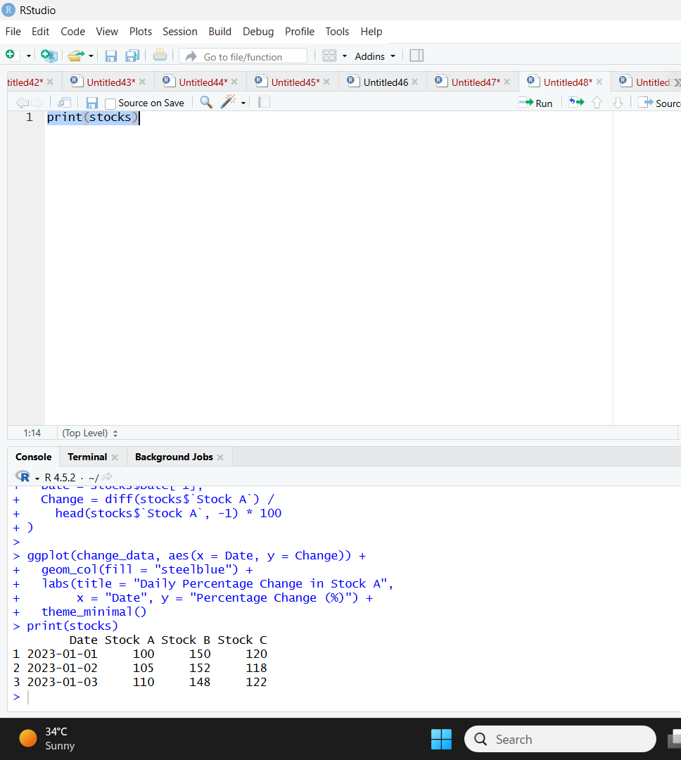
Observation: The table displays all three stock prices for each date, making daily comparisons straightforward.
4. Tableau dashboard
Aim: To combine the stock price line chart, Stock A percentage-change bar chart, and stock price table into an interactive dashboard.
Algorithm:
- Import the stock dataset into Tableau.
- Create a line chart for all three stocks.
- Calculate Stock A's percentage change.
- Create a bar chart for the daily percentage change.
- Create a stock price table.
- Combine the views in a dashboard and add date filters.
Procedure in Tableau:
- Connect to the stock dataset and ensure Date is recognized as a date field.
- Pivot the three stock price columns into Stock and Price fields.
- Create the line chart using Date on Columns, Price on Rows, and Stock on Color.
- Create a calculated field for Stock A's daily percentage change:
(SUM([Stock A]) - LOOKUP(SUM([Stock A]), -1))
/
LOOKUP(SUM([Stock A]), -1) * 100
- Use Date and the calculated field to build the percentage-change bar chart. Configure the table calculation to compute using Date in ascending order.
- Create a table containing Date, Stock A, Stock B, and Stock C.
- Combine the worksheets into a dashboard and add a date filter.
Observation: The dashboard provides an overview of stock price trends, daily percentage changes, and individual daily prices. Percentage change is calculated relative to the previous date.

